Jenkins pipelines Challenge
Task 1 — Create a Declarative Pipeline in Jenkins
Step 1: Open Jenkins
Open your Jenkins URL in your browser. If Jenkins is installed on this EC2 instance, use:
http://<EC2-PUBLIC-IP>:8080
http://54.144.225.176:8080/
Replace <EC2-PUBLIC-IP> with your instance's public IP address. Ensure the EC2 security group allows port 8080 from your IP address.
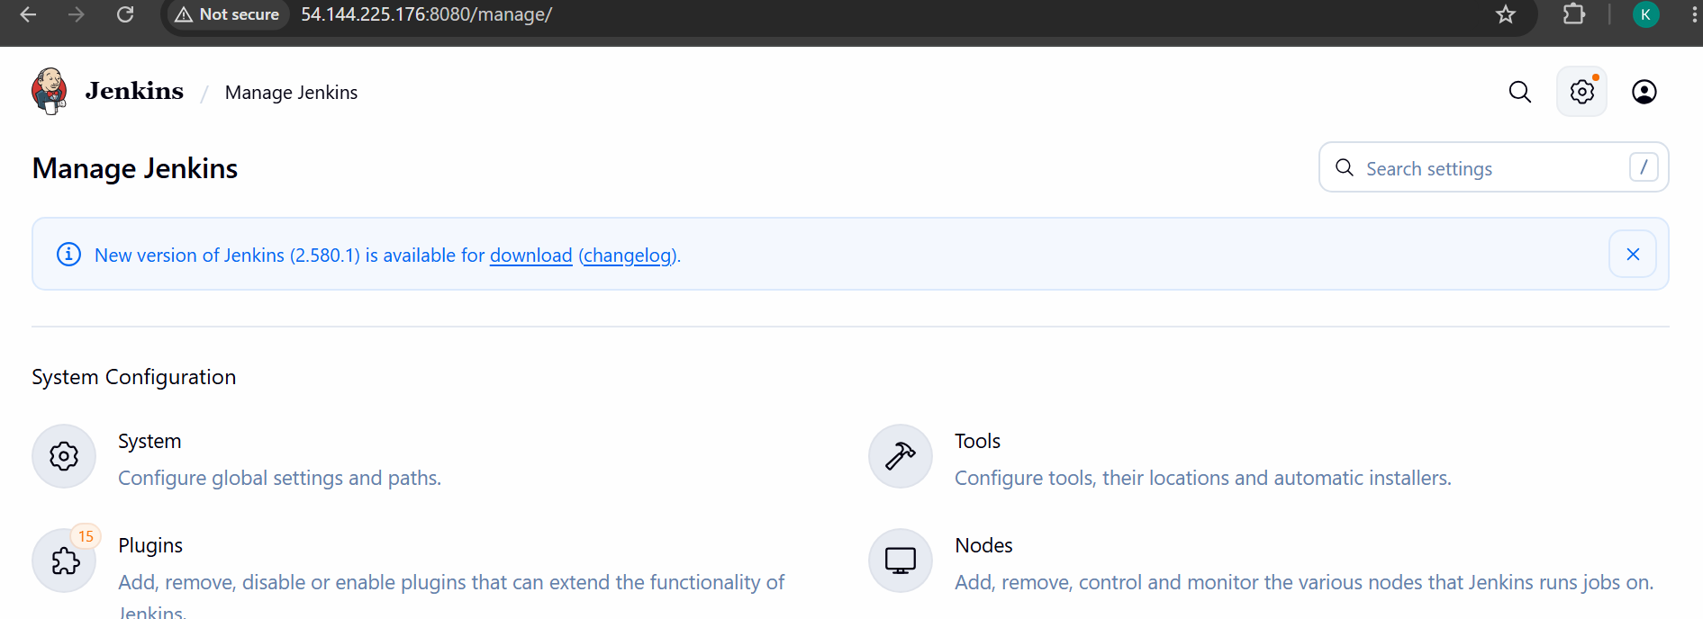
Step 2: Create the job
- Click New Item.
- Enter the job name declarative-maven-job.
- Select Pipeline.
- Click OK.
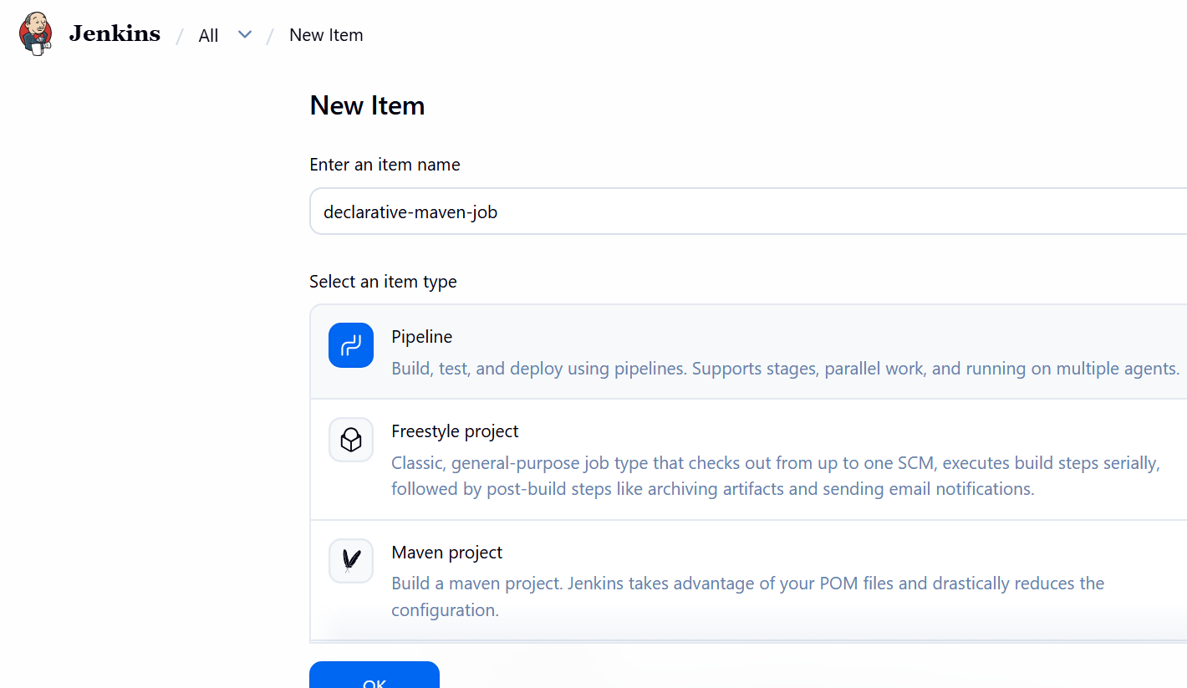
- Scroll down to the Pipeline section.
- Set Definition to Pipeline script.
Step 3: Paste the Jenkinsfile
pipeline {
agent any
stages {
stage('Checkout') {
steps {
git branch: 'master',
url: 'https://github.com/narayana-28/spring3-mvc-maven-xml-hello-world-1.git'
}
}
stage('Build') {
steps {
sh 'mvn -B clean package'
}
}
stage('Verify') {
steps {
sh 'ls -la'
sh 'ls -la target'
echo 'Build verification completed.'
}
}
}
post {
success {
echo 'Declarative pipeline completed successfully!'
}
failure {
echo 'Build failed. Check Console Output.'
}
always {
echo 'Pipeline execution finished.'
}
}
}
Click Save.
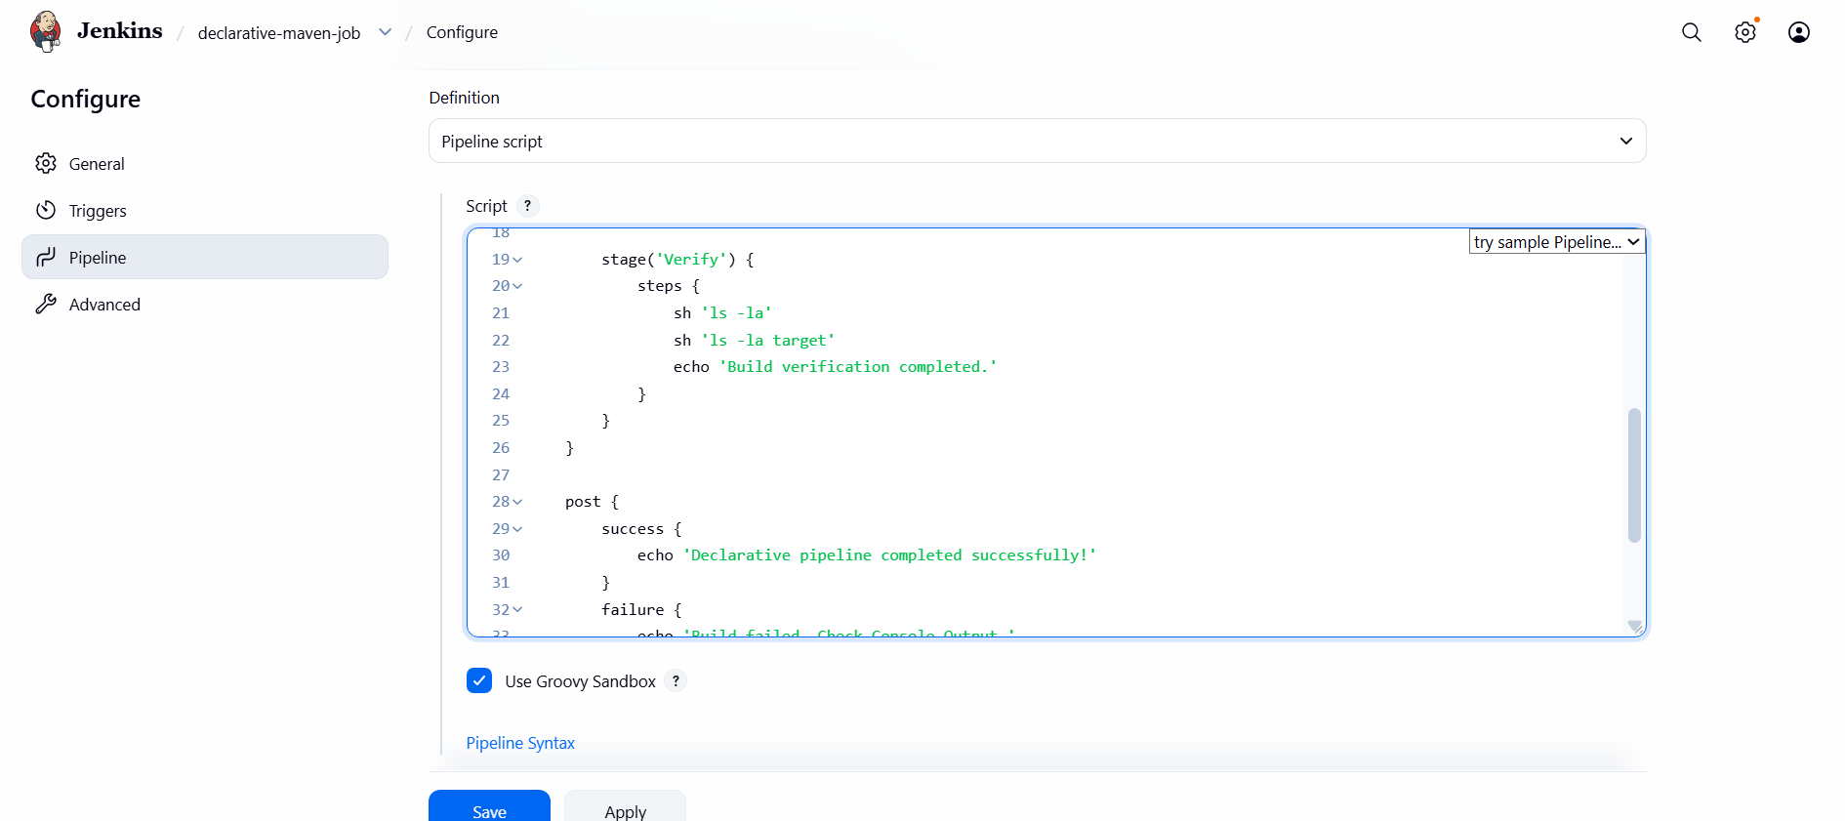
Before – fork to your gihub repo and Update pom.xml in GitHub
Open the repository:
spring3-mvc-maven-xml-hello-world-1 on GitHub
- Open pom.xml.
- Click the pencil icon to edit it.
- Find the existing <build> section and its <plugins> element.
- Add this plugin inside <plugins>, alongside the existing plugins:
<plugin>
<groupId>org.apache.maven.plugins</groupId>
<artifactId>maven-war-plugin</artifactId>
<version>3.4.0</version>
</plugin>
Step 4: Run the pipeline
- Click Build Now.
- Under Build History, click the new build number.
- Click Console Output.
- Wait for the build to finish.
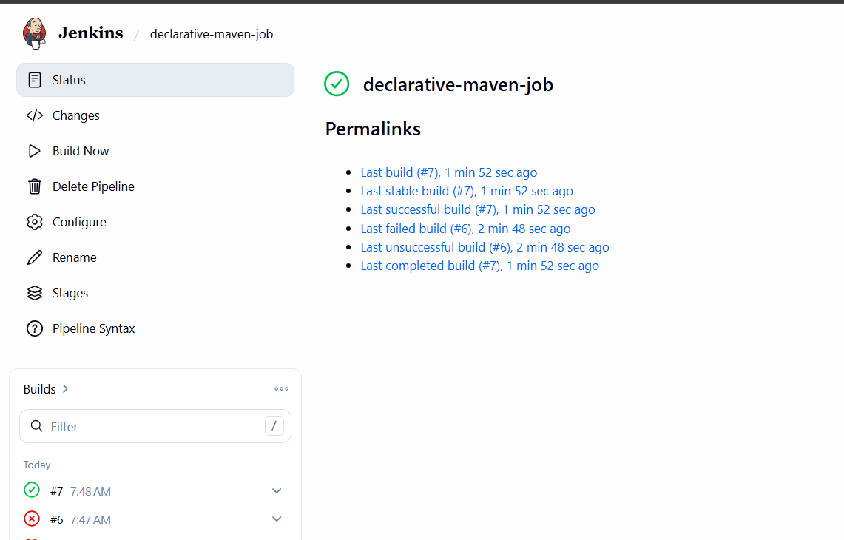
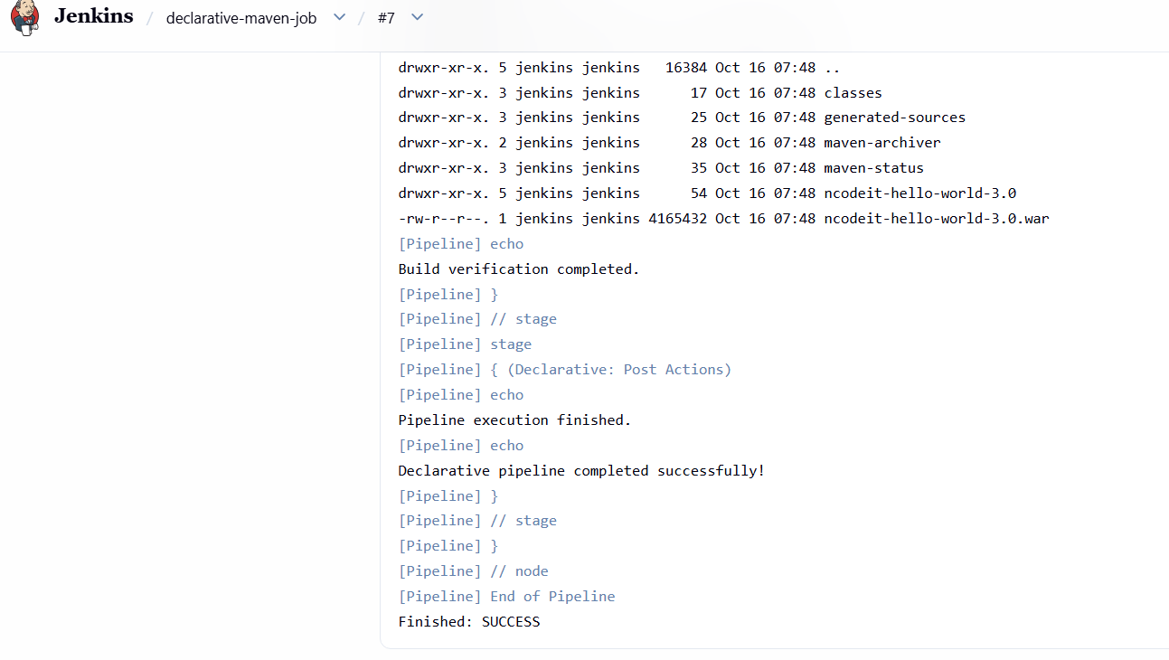
Task 2 — Scripted Jenkins Pipeline.
Step 1 — Create a new Jenkins job
- Open Jenkins: http://54.144.225.176:8080
- Click New Item.
- Enter the job name: scripted-maven-job
- Select Pipeline.
- Click OK.
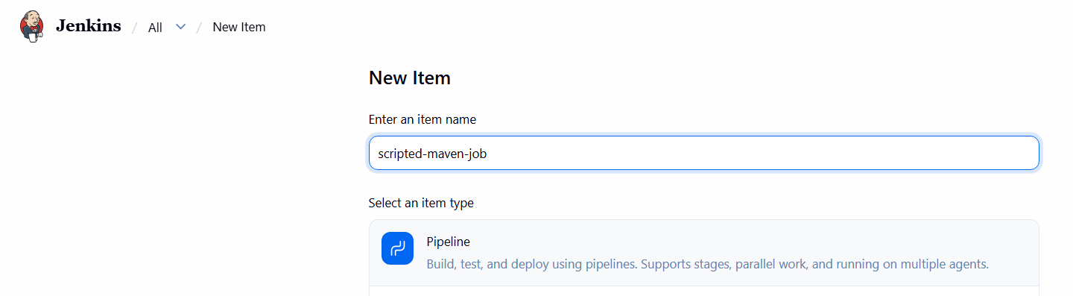
- Scroll down to the Pipeline section.
- Set Definition to Pipeline script.
Step 2 — Add this Scripted Pipeline

node {
stage('Checkout') {
git branch: 'master',
url: 'https://github.com/narayana-28/spring3-mvc-maven-xml-hello-world-1.git'
}
stage('Build') {
sh 'mvn -B clean package'
}
stage('Verify') {
sh 'ls -la'
sh 'ls -la target'
echo 'Build verification completed.'
}
stage('Result') {
if (currentBuild.currentResult == 'SUCCESS') {
echo 'Scripted pipeline completed successfully!'
} else {
echo 'Scripted pipeline did not complete successfully.'
}
}
}
What is different from Task 1?
- Declarative pipeline: uses pipeline {}, agent, stages, and steps.
- Scripted pipeline: uses node {} and Groovy code directly, with stage() blocks.
- Both pipelines can perform checkout, build, and verification.
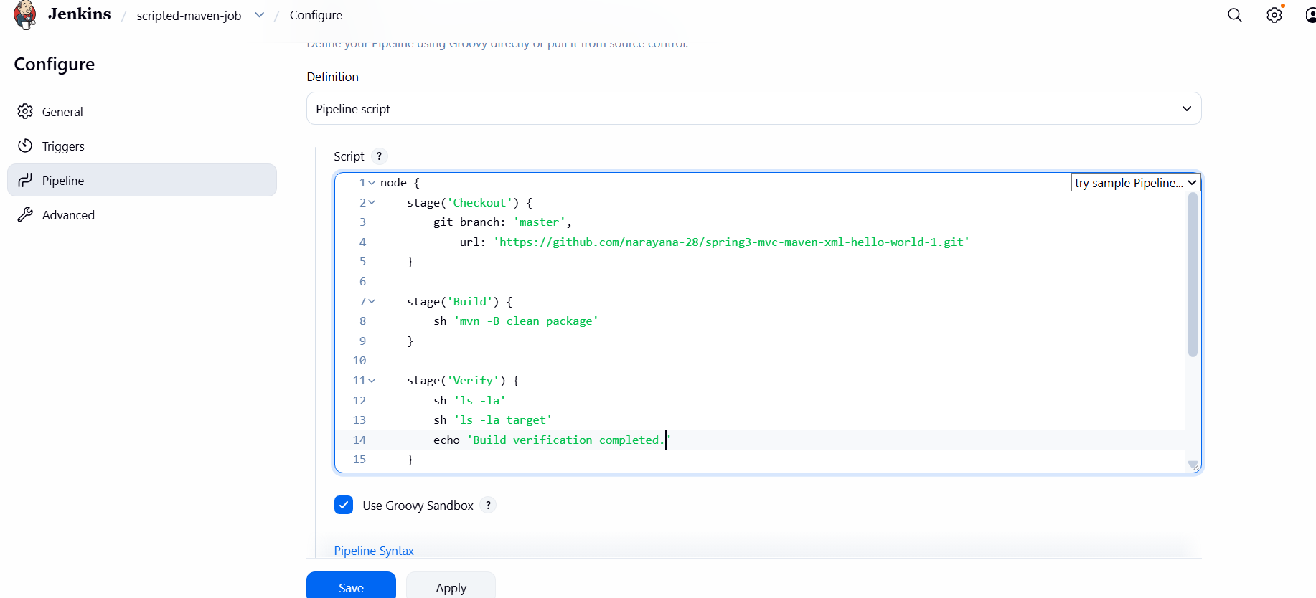
Step 3 — Run the job
- Click Save.
- Click Build Now.
- Open Console Output.
You should see Maven report BUILD SUCCESS and Jenkins finish with Finished: SUCCESS. 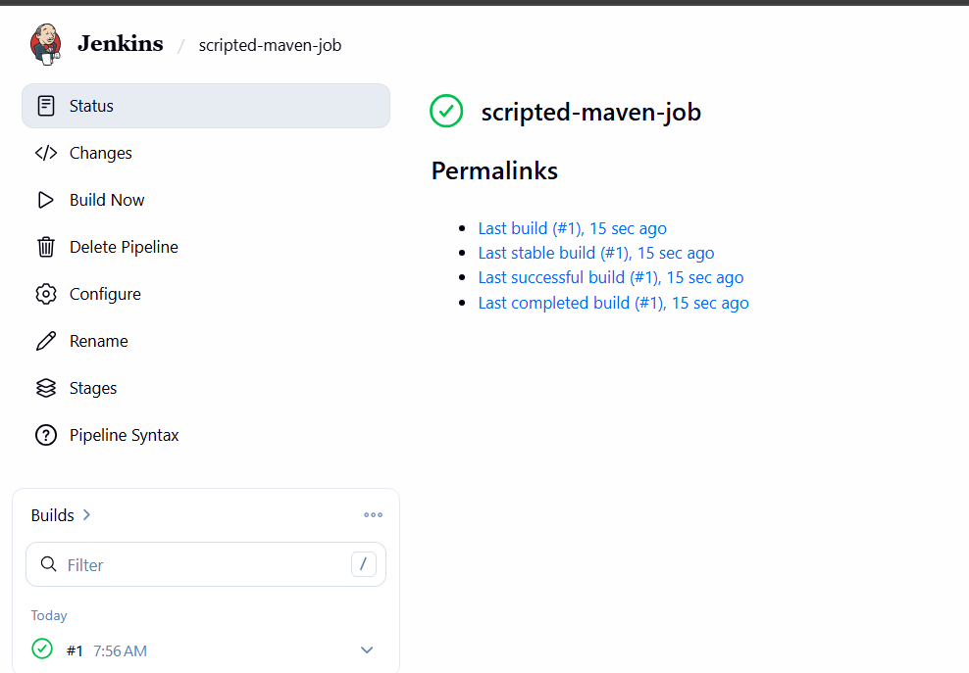

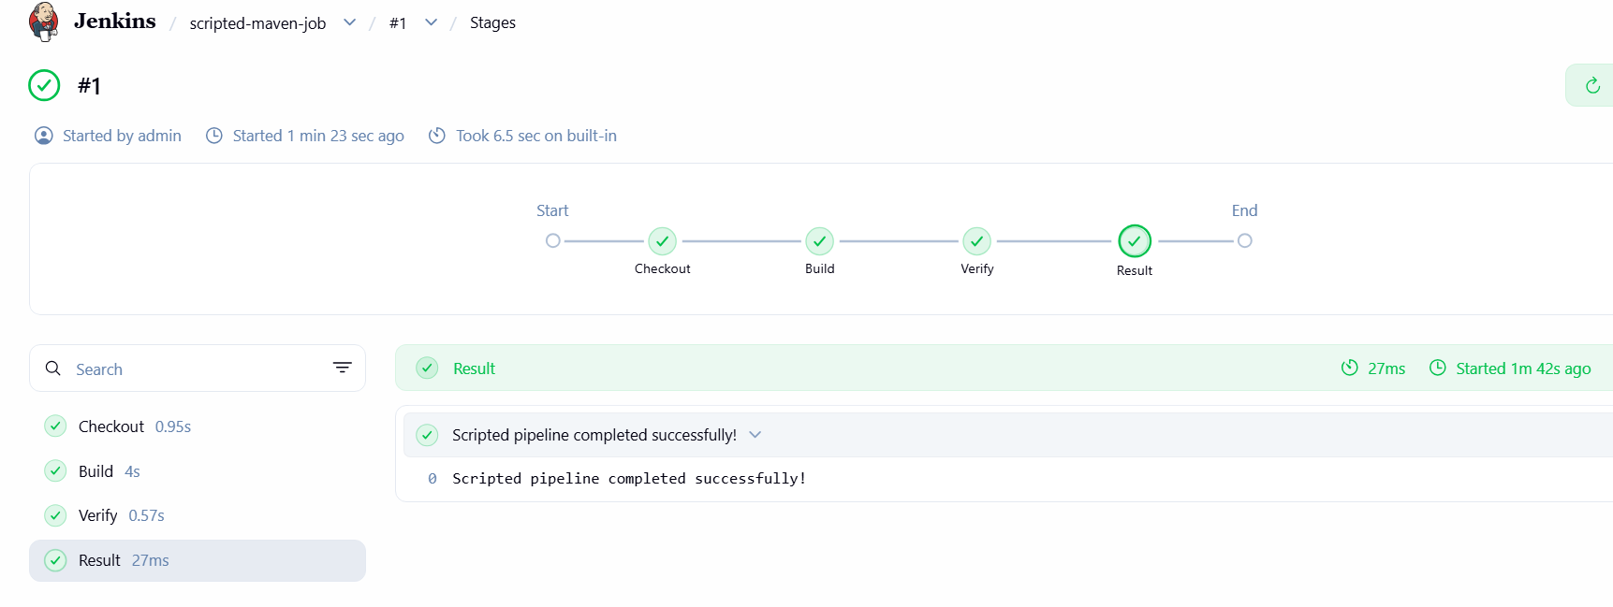
Task 3 — Parameterized Jenkins Pipeline.
Step 1 — Create the job
- In Jenkins, click New Item.
- Enter parameterized-maven-job.
- Select Pipeline and click OK.
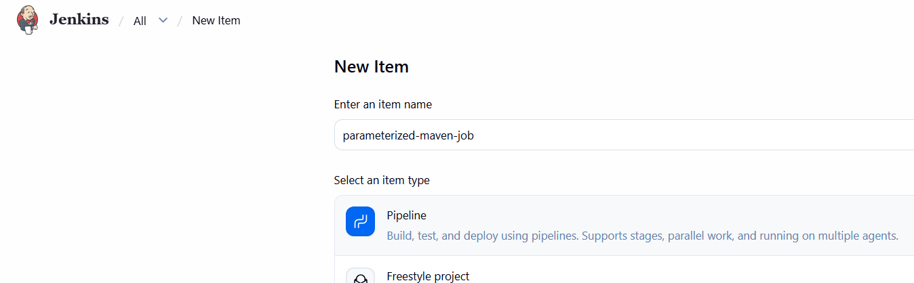
- Select This project is parameterized.
- Add these three parameters:
Parameter 1 — String
- Name: GIT_BRANCH
- Default Value: master
- Description: Git branch to build
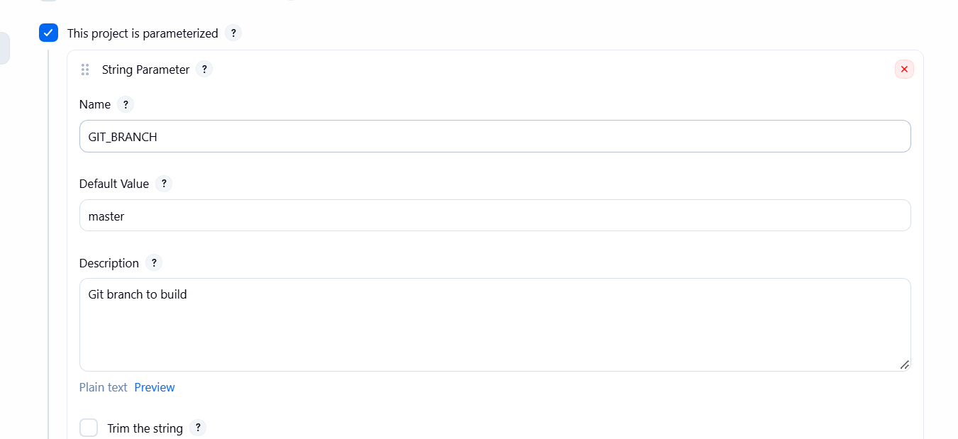
Parameter 2 — Choice
- Name: MAVEN_GOALS
- Choices:
- clean package
- clean verify
- clean install
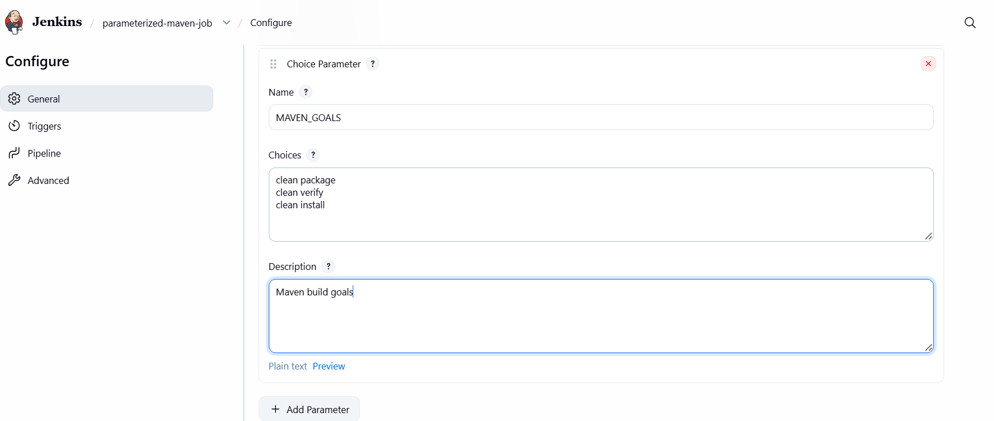
- Description: Maven build goals
Parameter 3 — Boolean
- Name: SKIP_TESTS
- Default Value: unchecked
- Description: Skip test execution when enabled
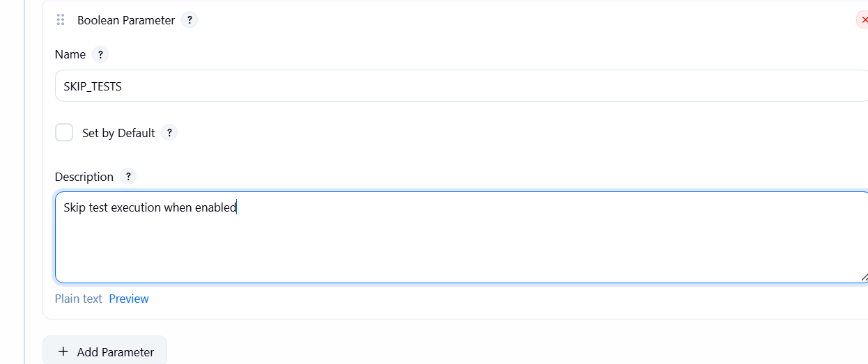
Step 2 — Add the pipeline script
Scroll to the Pipeline section, select Pipeline script, and paste this code:
pipeline {
agent any
parameters {
string(
name: 'GIT_BRANCH',
defaultValue: 'master',
description: 'Git branch to build'
)
choice(
name: 'MAVEN_GOALS',
choices: ['clean package', 'clean verify', 'clean install'],
description: 'Maven build goals'
)
booleanParam(
name: 'SKIP_TESTS',
defaultValue: false,
description: 'Skip test execution when enabled'
)
}
stages {
stage('Checkout') {
steps {
git branch: params.GIT_BRANCH,
url: 'https://github.com/narayana-28/spring3-mvc-maven-xml-hello-world-1.git'
}
}
stage('Build') {
steps {
script {
def goals = params.MAVEN_GOALS
if (params.SKIP_TESTS) {
goals += ' -DskipTests'
}
sh "mvn -B ${goals}"
}
}
}
stage('Verify') {
steps {
sh 'ls -lh target'
echo "Branch: ${params.GIT_BRANCH}"
echo "Maven goals: ${params.MAVEN_GOALS}"
echo "Skip tests: ${params.SKIP_TESTS}"
}
}
}
post {
success {
echo 'Parameterized pipeline completed successfully!'
}
failure {
echo 'Build failed. Check Console Output.'
}
always {
echo 'Pipeline execution finished.'
}
}
}
Note: -DskipTests skips running tests but does not skip compiling test sources.
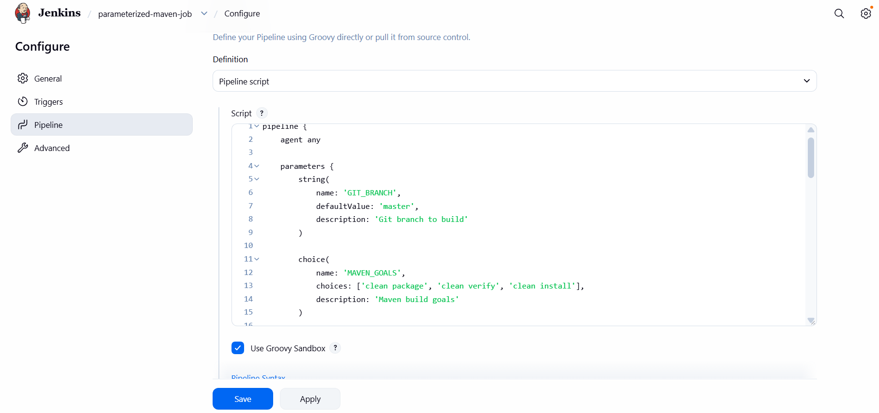
Step 3 — Save and run
- Click Save.
- Click Build with Parameters.
- Keep the defaults for your first run:
  - GIT_BRANCH: master
  - MAVEN_GOALS: clean package
  - SKIP_TESTS: unchecked
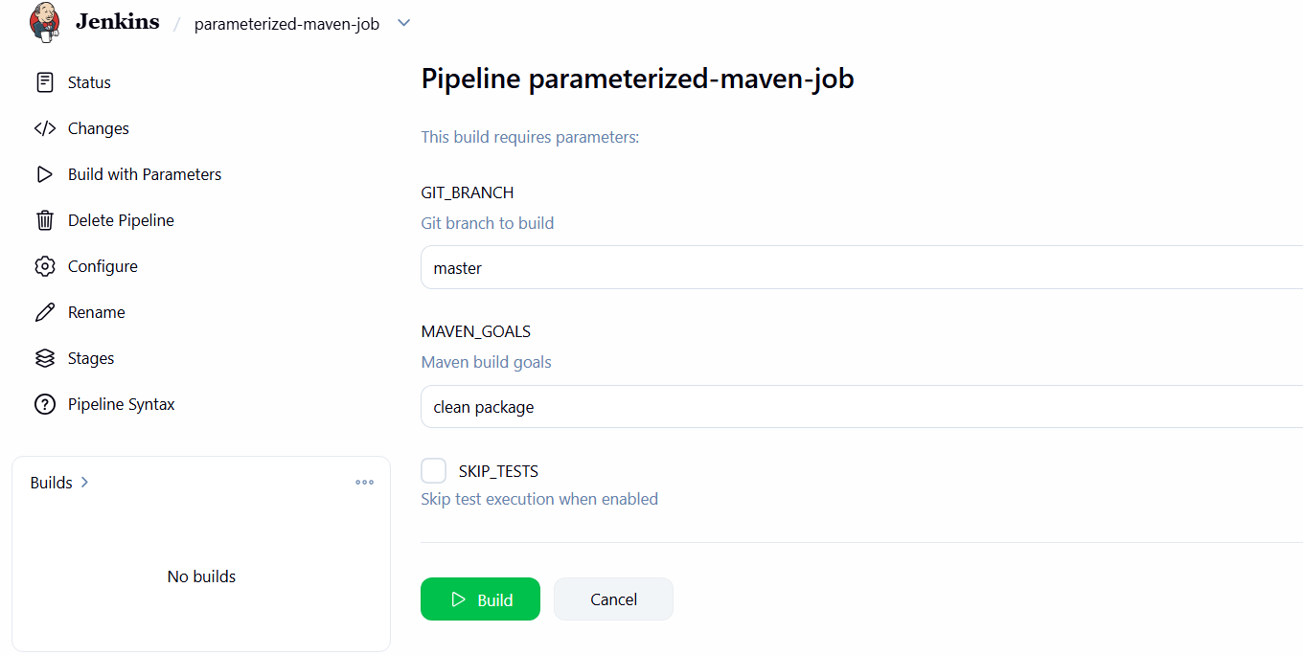
- Click Build.
- Open Console Output and check the result.
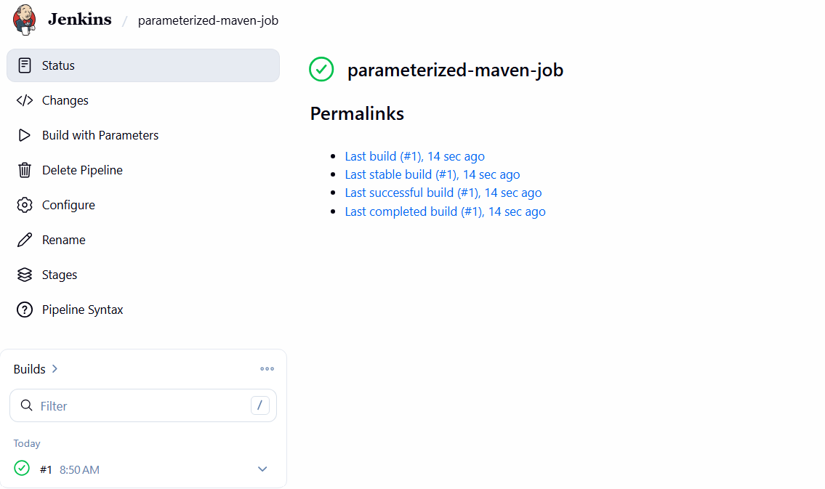
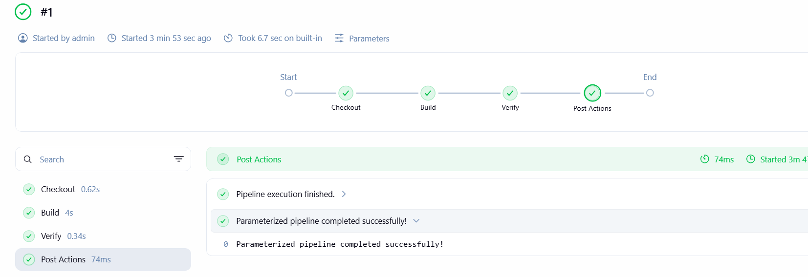
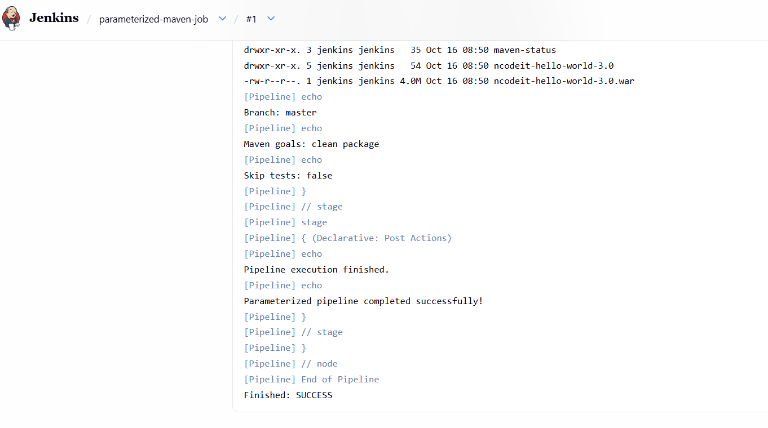
Task 4 — Write sample skeletons for Declarative and Scripted pipelines
A pipeline skeleton is a reusable template. It shows the structure of stages without implementing a complete application build. Jenkins supports both syntaxes.
 Jenkins +1
Step 1 — Declarative pipeline skeleton
pipeline {
agent any
stages {
stage('Checkout') {
steps {
echo 'Checkout source code'
}
}
stage('Build') {
steps {
echo 'Build the application'
}
}
stage('Test') {
steps {
echo 'Test the application'
}
}
stage('Deploy') {
steps {
echo 'Deploy the application'
}
}
}
post {
success {
echo 'Pipeline completed successfully'
}
failure {
echo 'Pipeline failed'
}
always {
echo 'Pipeline execution finished'
}
}
}
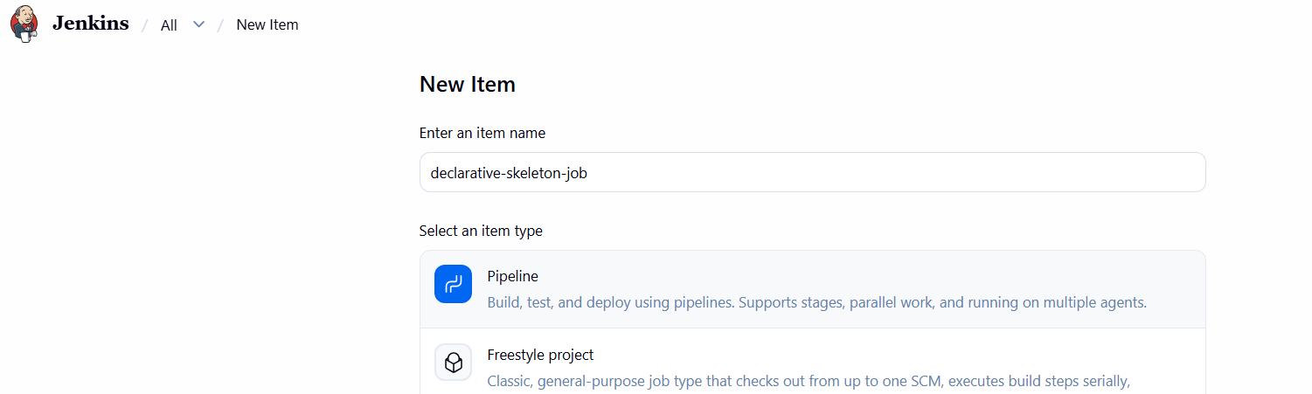
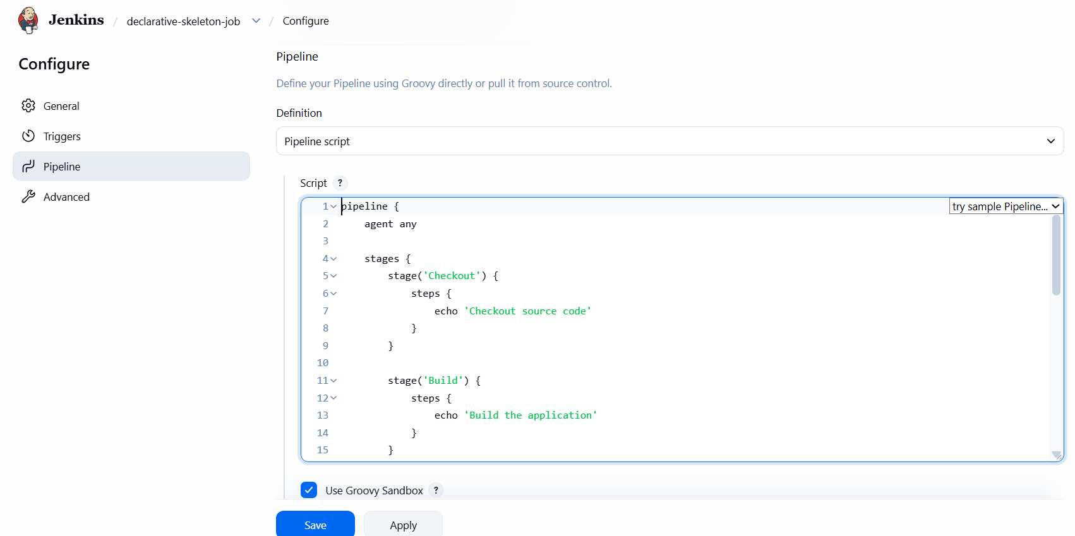
Step 2 — Scripted pipeline skeleton
node {
stage('Checkout') {
echo 'Checkout source code'
}
stage('Build') {
echo 'Build the application'
}
stage('Test') {
echo 'Test the application'
}
stage('Deploy') {
echo 'Deploy the application'
}
echo 'Scripted pipeline execution finished'
}
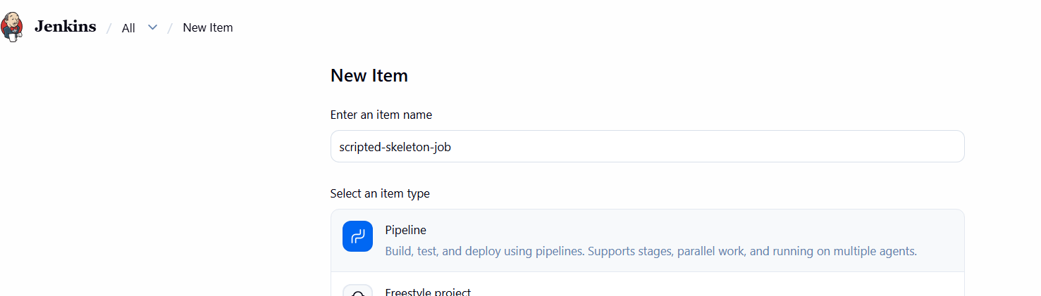
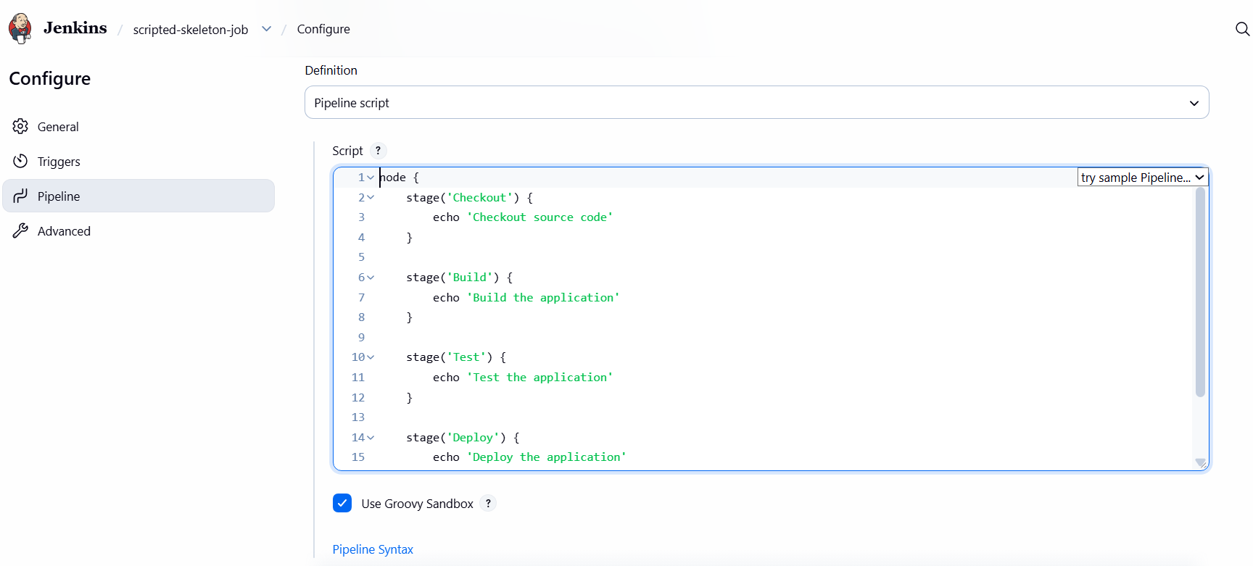
Step 3 — Understand the differences
Feature | Declarative | Scripted
Main block | pipeline {} | node {}
Execution location | agent any | node allocates an executor and workspace
Stages | Inside stages {} | Directly inside node {}
Stage steps | Inside steps {} | Written directly in the stage
Conditions and loops | Supported, with some logic in script {} | Flexible Groovy control flow
Post-build handling | post {} | Commonly try/catch/finally or result checks
These are skeletons, so the echo statements are placeholders rather than real checkout, build, test, or deployment operations.
Step 4 — Run the skeletons in Jenkins
For practice, create two jobs:
- declarative-skeleton-job — select Pipeline script and paste the Declarative example.
- scripted-skeleton-job — select Pipeline script and paste the Scripted example.
For each job, click Save → Build Now → Console Output. Both should finish successfully.
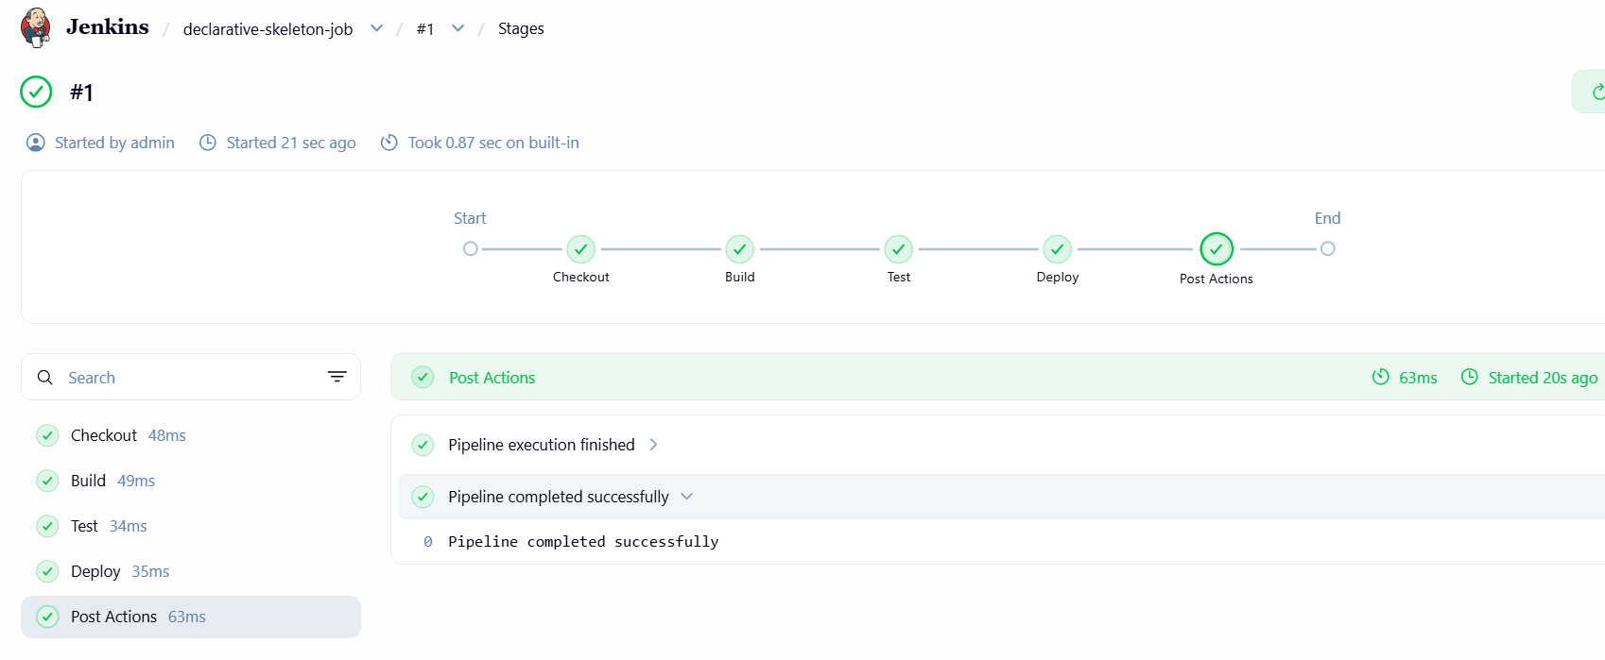
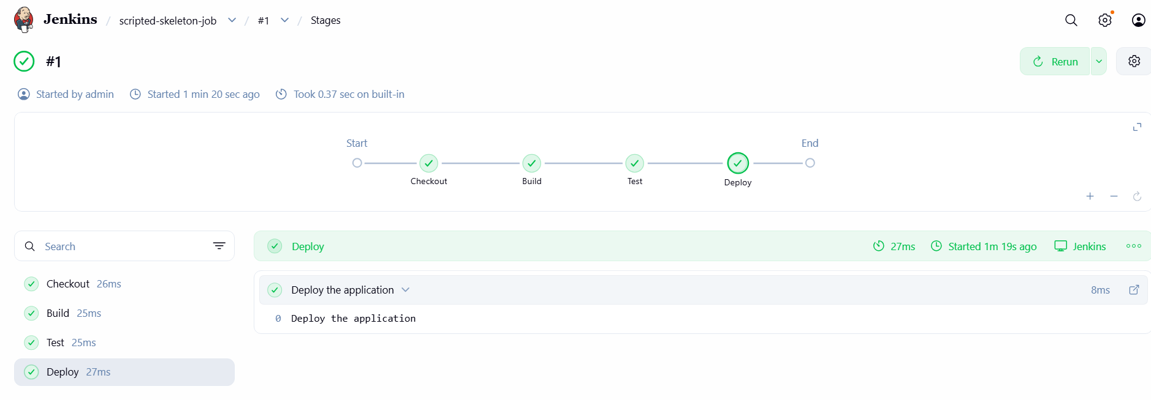

Expected result: Finished: SUCCESS
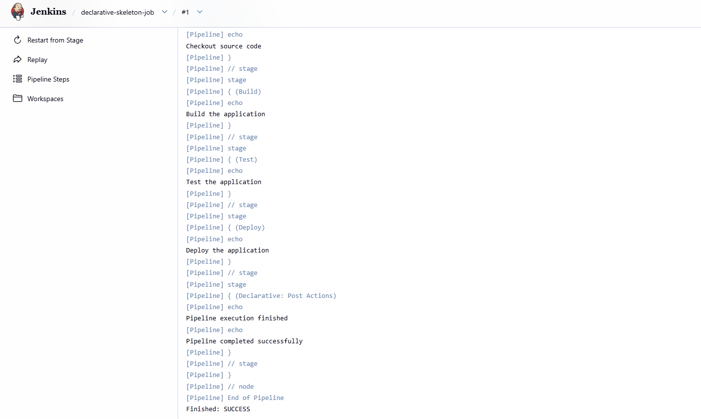
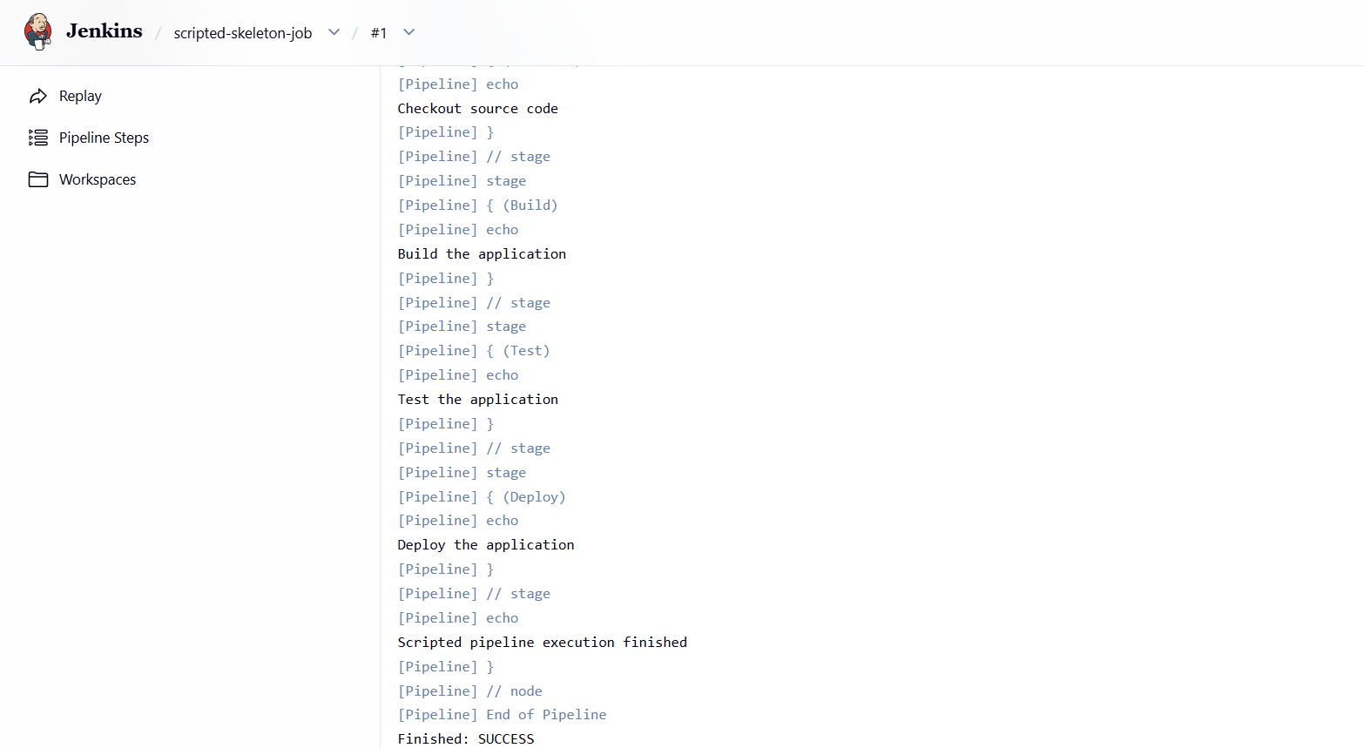
Task 5 — Create a Declarative Jenkins job for the Customer App
We'll create a new job named customer-app-job and build the feature-1.1 branch. We'll use Jenkins Declarative Pipeline syntax, which organizes the workflow into stages.
Jenkins +1
Step 1 — Create the job
- Open Jenkins: http://54.144.225.176:8080
- Click New Item.
- Enter customer-app-job.
- Select Pipeline, then click OK.
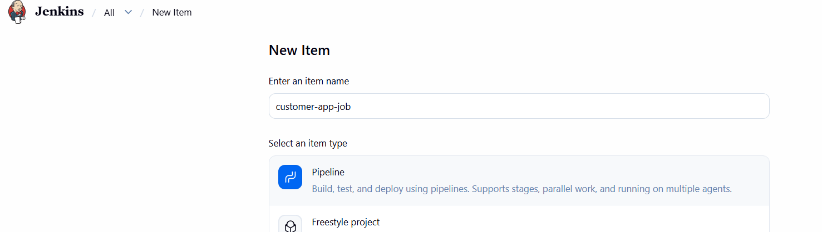
- Scroll down to the Pipeline section.
- Set Definition to Pipeline script.
Step 2 — Enter this pipeline
Use the exact repository URL and branch from your lab instructions.
pipeline {
agent any
stages {
stage('Checkout') {
steps { git branch: 'feature-1.1',
url: 'https://github.com/betawins/sabear_simplecutomerapp.git'
}
}
stage('Inspect Project') {
steps { sh 'pwd'
sh 'ls -la'
sh 'find . -maxdepth 2 -type f | sort | head -80'
}
}
}
post {
success {
echo 'Customer App source checkout completed successfully!'
}
failure {
echo 'Customer App pipeline failed. Check Console Output.'
}
always {
echo 'Customer App pipeline execution finished.'
}
}
}
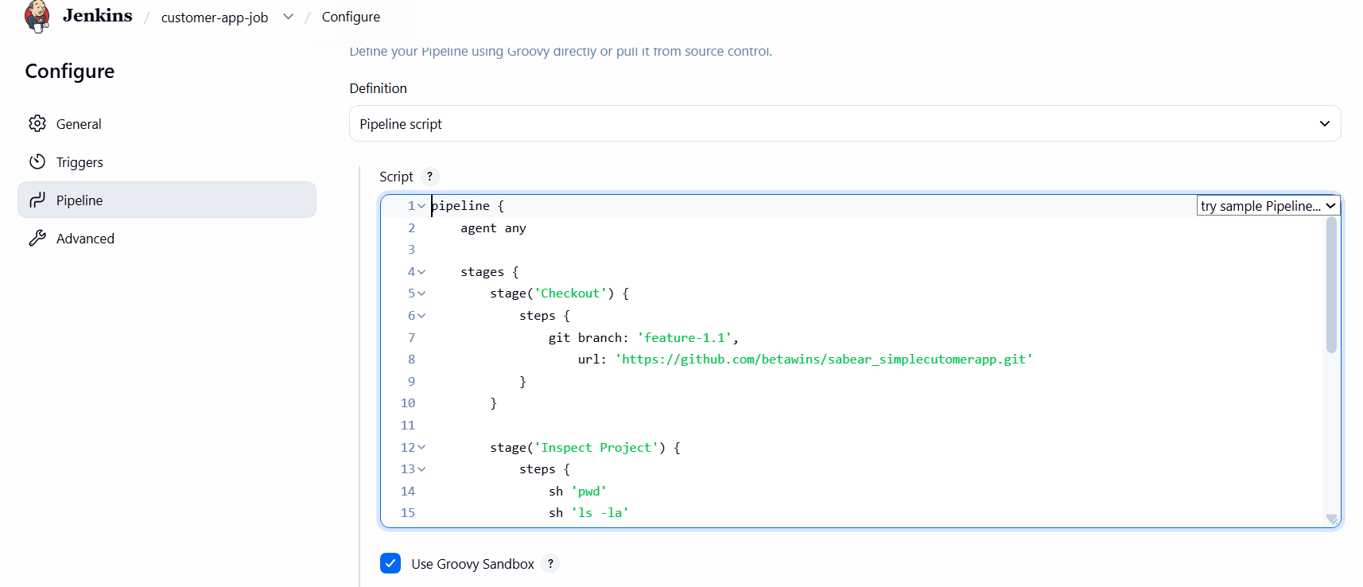
This first run deliberately checks out and inspects the source code before choosing a build tool. It does not assume the project uses Maven or Node.js.
Step 3 — Save and run
- Click Save.
- Click Build Now.
- Open Console Output.
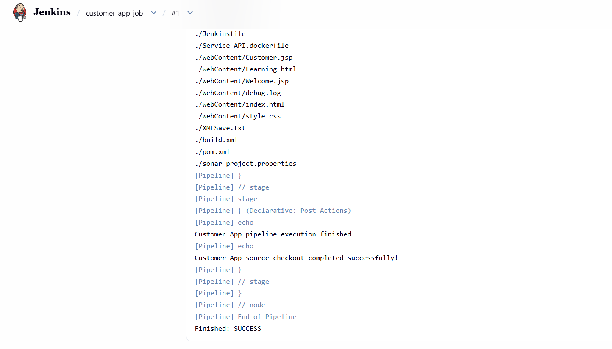
The expected result is Finished: SUCCESS. The build should show the feature-1.1 branch being checked out and list the project files.
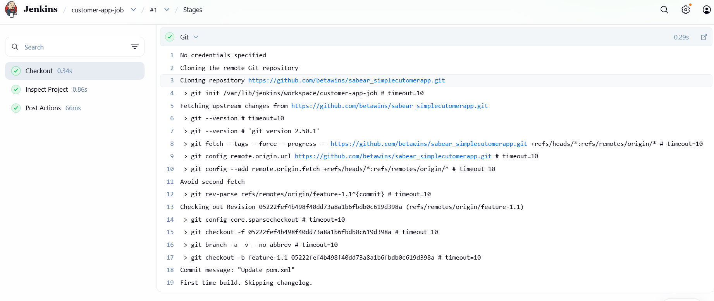
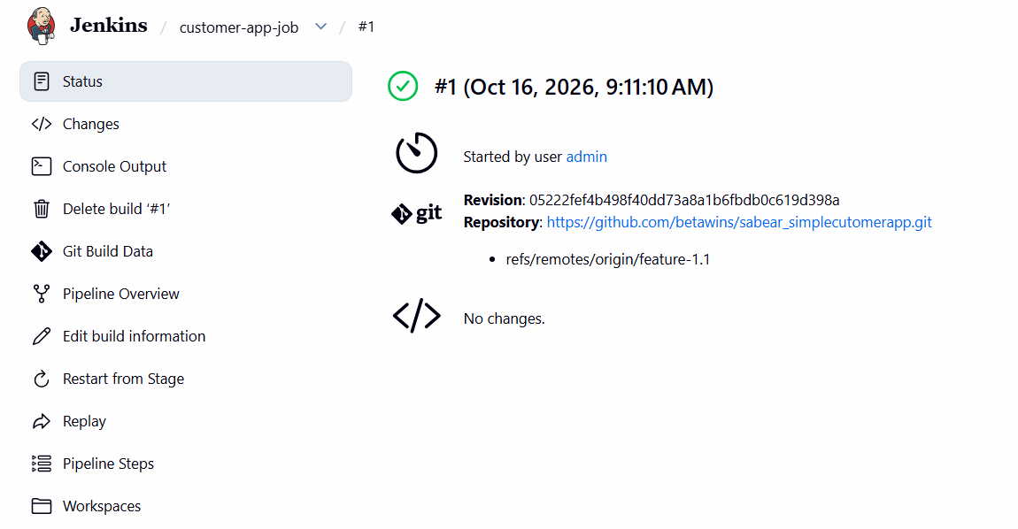
Task 6 — Trading UI Declarative Pipeline.
Step 1 — Create the Jenkins job
- Open Jenkins: http://54.144.225.176:8080
- Click New Item.
- Enter the job name: trading-ui-job.
- Select Pipeline, then click OK.
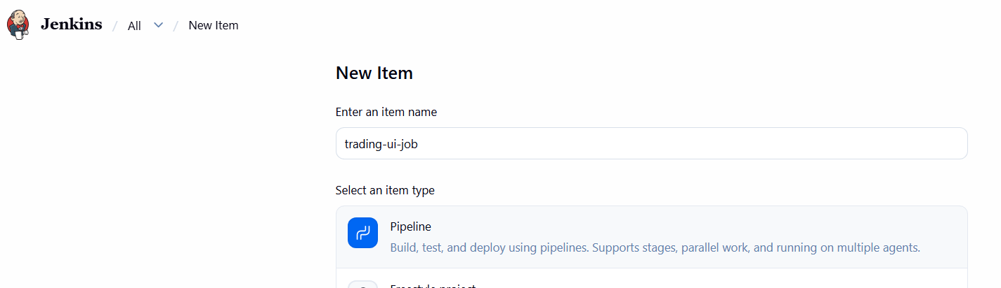
- Scroll down to the Pipeline section.
- Set Definition to Pipeline script.
Step 2 — Add the pipeline script
Paste this into the Script box:
pipeline {
agent any
stages {
stage('Checkout') {
steps {
git branch: 'master',
url: 'https://github.com/betawins/Trading-UI.git'
}
}
stage('Inspect Project') {
steps {
sh 'pwd'
sh 'ls -la'
sh 'find . -maxdepth 2 -type f | sort | head -80'
}
}
}
post {
success {
echo 'Trading UI source checkout completed successfully!'
}
failure {
echo 'Trading UI pipeline failed. Check Console Output.'
}
always {
echo 'Trading UI pipeline execution finished.'
}
}
}
I used main as the expected branch. If checkout reports that the branch does not exist, we'll identify the repository's actual default branch and correct it.
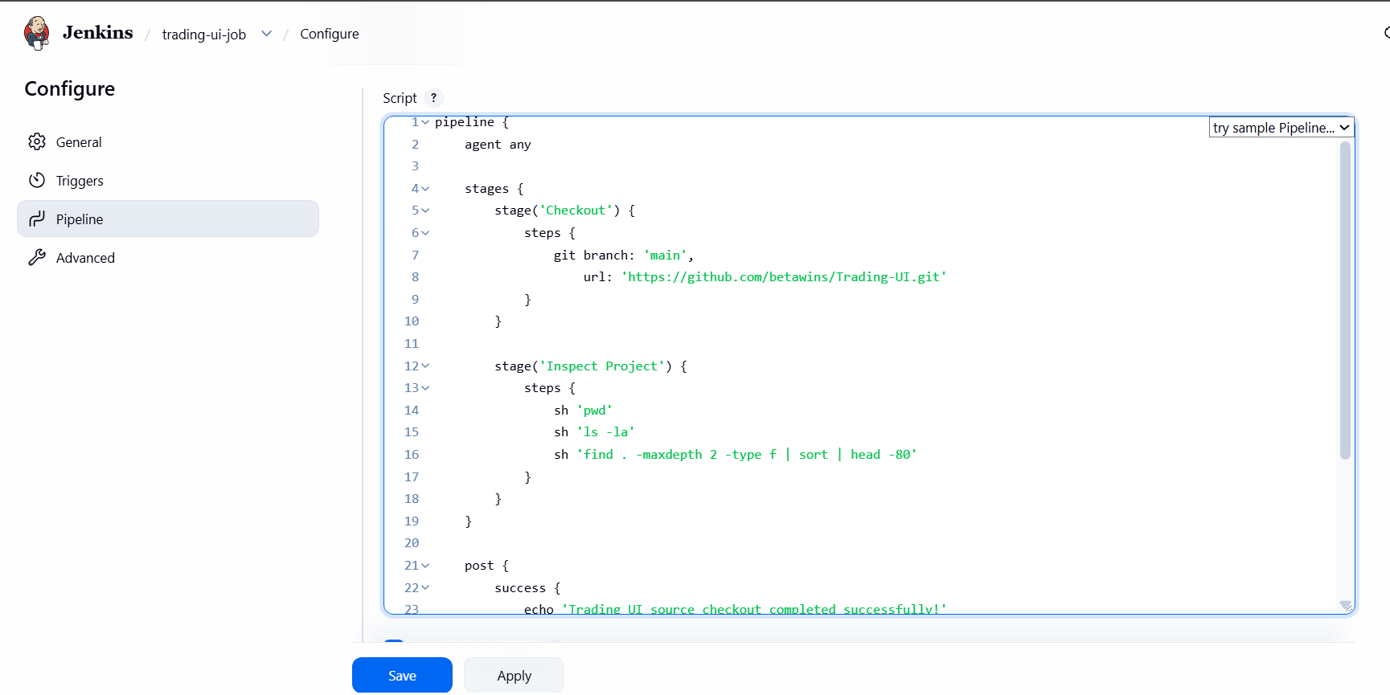
Step 3 — Save and run
- Click Save.
- Click Build Now.
- Open Console Output.
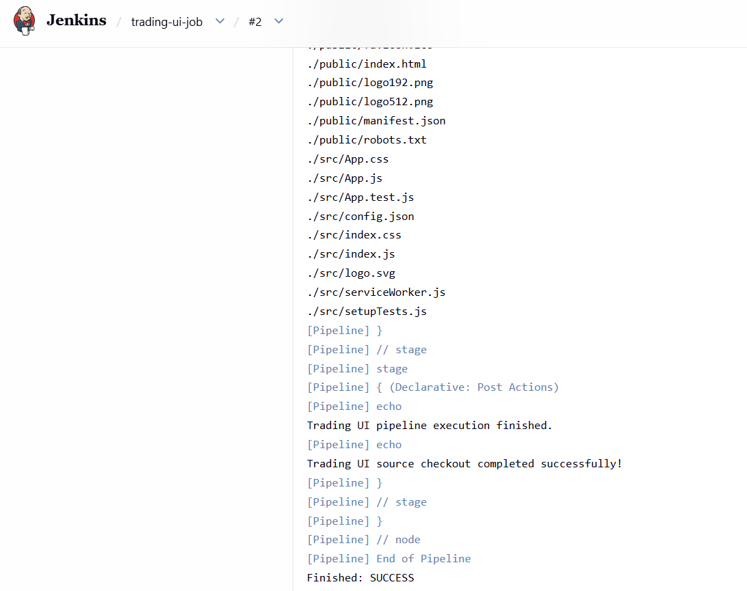
The initial pipeline only checks out and inspects the project. It doesn't build the UI yet; we need to confirm its build files and dependencies first.
Expected result: Finished: SUCCESS
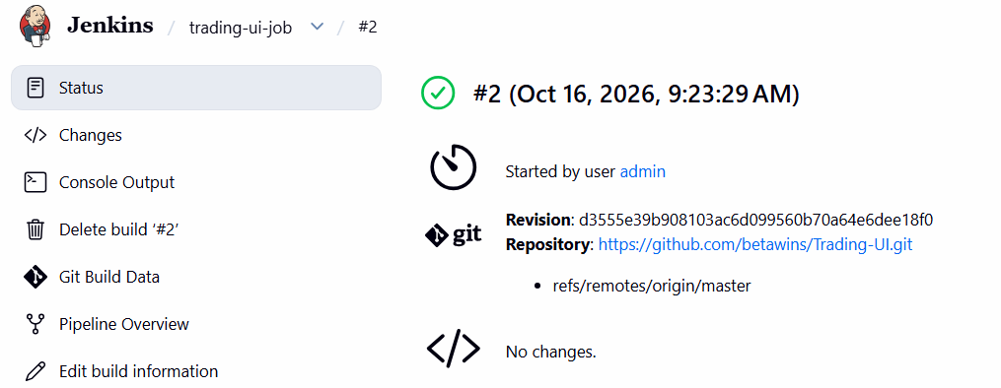
Task 7 — Execute parallel stages using a Jenkins pipeline.
Step 1 — Create a new Jenkins job
- Open Jenkins: http://54.144.225.176:8080
- Click New Item.
- Enter parallel-stages-job.
- Select Pipeline and click OK.
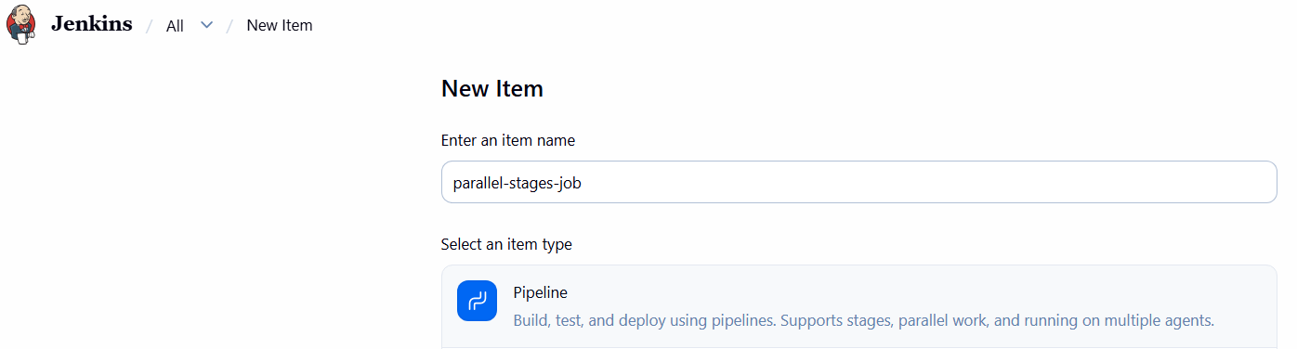
- Under Pipeline, select Pipeline script.
Step 2 — Paste this Declarative Pipeline
This pipeline checks out your working Maven project, runs three independent checks in parallel, and then builds the application.
pipeline { agent any
stages {
stage('Checkout') {
steps {
git branch: 'master',
url: 'https://github.com/narayana-28/spring3-mvc-maven-xml-hello-world-1.git'
}
}
stage('Parallel Checks') {
parallel {
stage('Java Check') {
steps {
sh 'java -version' }
}
stage('Maven Check') {
steps {
sh 'mvn -version' }
}
stage('Git Check') {
steps {
sh 'git --version'
sh 'git log -1 --oneline' }
}
}
}
stage('Build') {
steps {
sh 'mvn -B clean package'
sh 'ls -lh target'
}
}
}
post {
success { echo 'Parallel pipeline completed successfully!'
}
failure { echo 'Pipeline failed. Check Console Output.'
}
always { echo 'Parallel pipeline execution finished.'
}
}
}
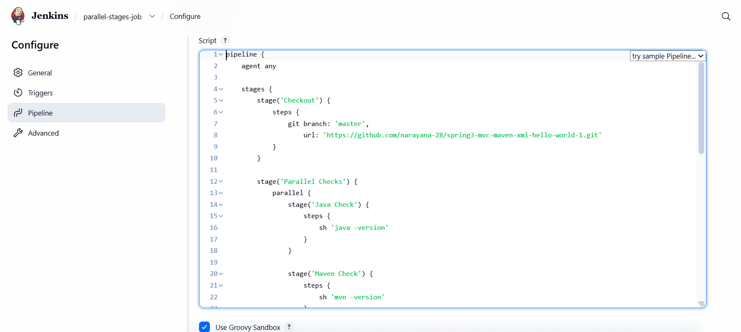
Step 3 — Save and execute
- Click Save.
- Click Build Now.
- Open Console Output.
- Observe the Parallel Checks stage and its three branches:
  - Java Check
  - Maven Check
  - Git Check
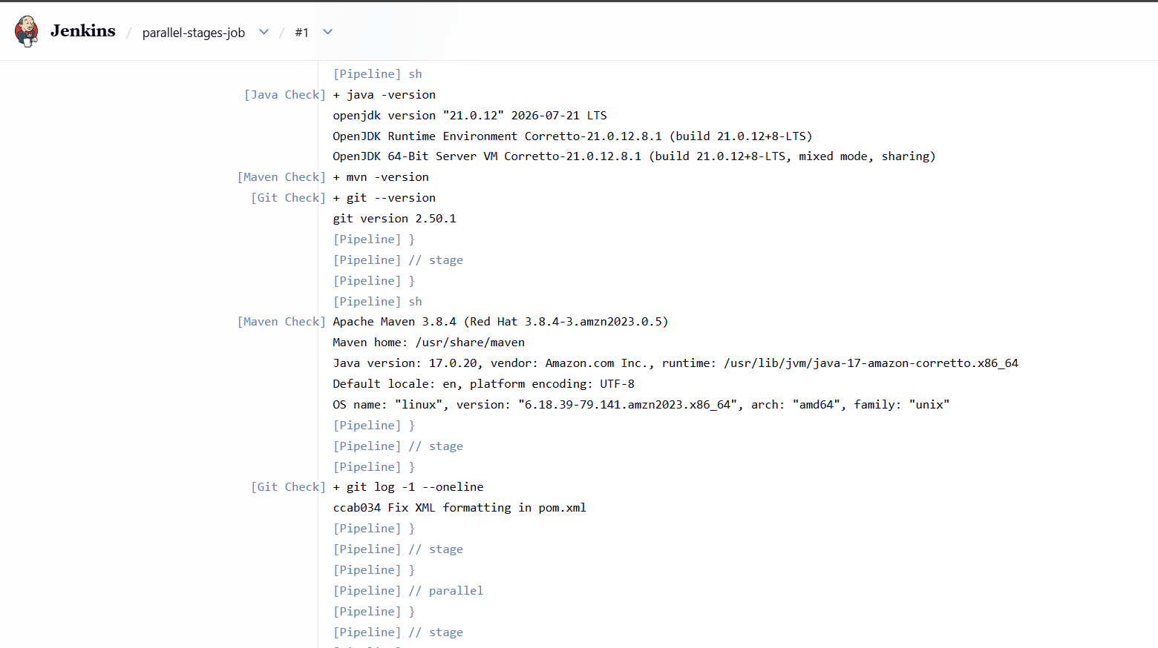
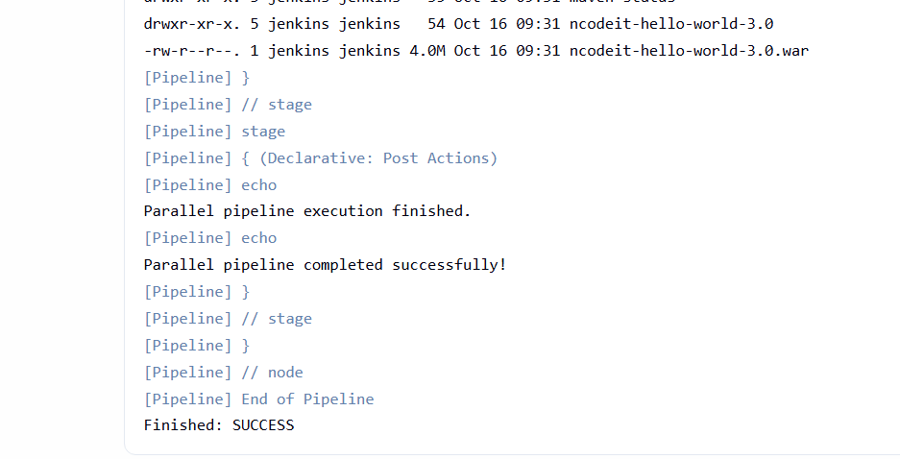
These checks can execute concurrently. The Build stage starts after all three branches finish successfully.
Expected result: Finished: SUCCESS
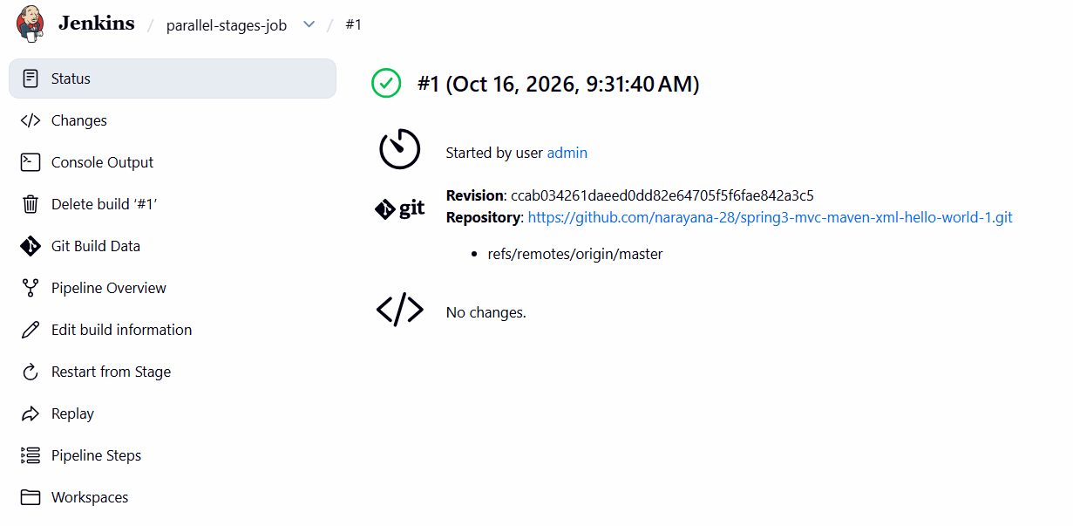
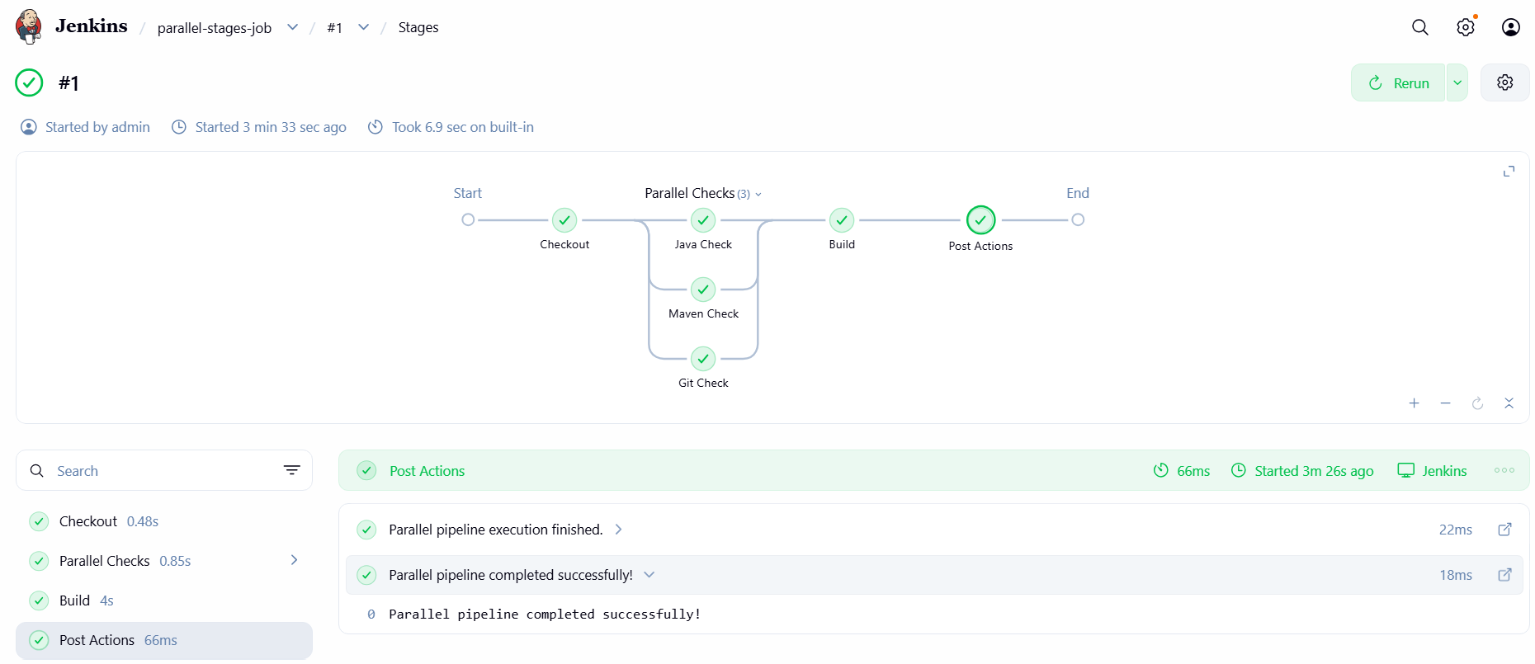
Task 8 — Execute Jenkins pipeline stages using Shared Libraries.
What is a Jenkins Shared Library?
A Shared Library lets you store reusable pipeline code in a separate Git repository. Multiple Jenkins jobs can call the same functions instead of duplicating pipeline code in every Jenkinsfile.
We'll create a small library with checkout, Maven build, and reporting functions, then call those functions from a Jenkins pipeline.
Step 1 — Create a GitHub repository for the Shared Library
Create a new public repository on your GitHub account named:
jenkins-shared-library
Keep it separate from your Maven application repository.
- Open GitHub — Create a new repository.
- Repository name: jenkins-shared-library.
- Select Public for this learning lab.
- Select Add a README file.
- Click Create repository.
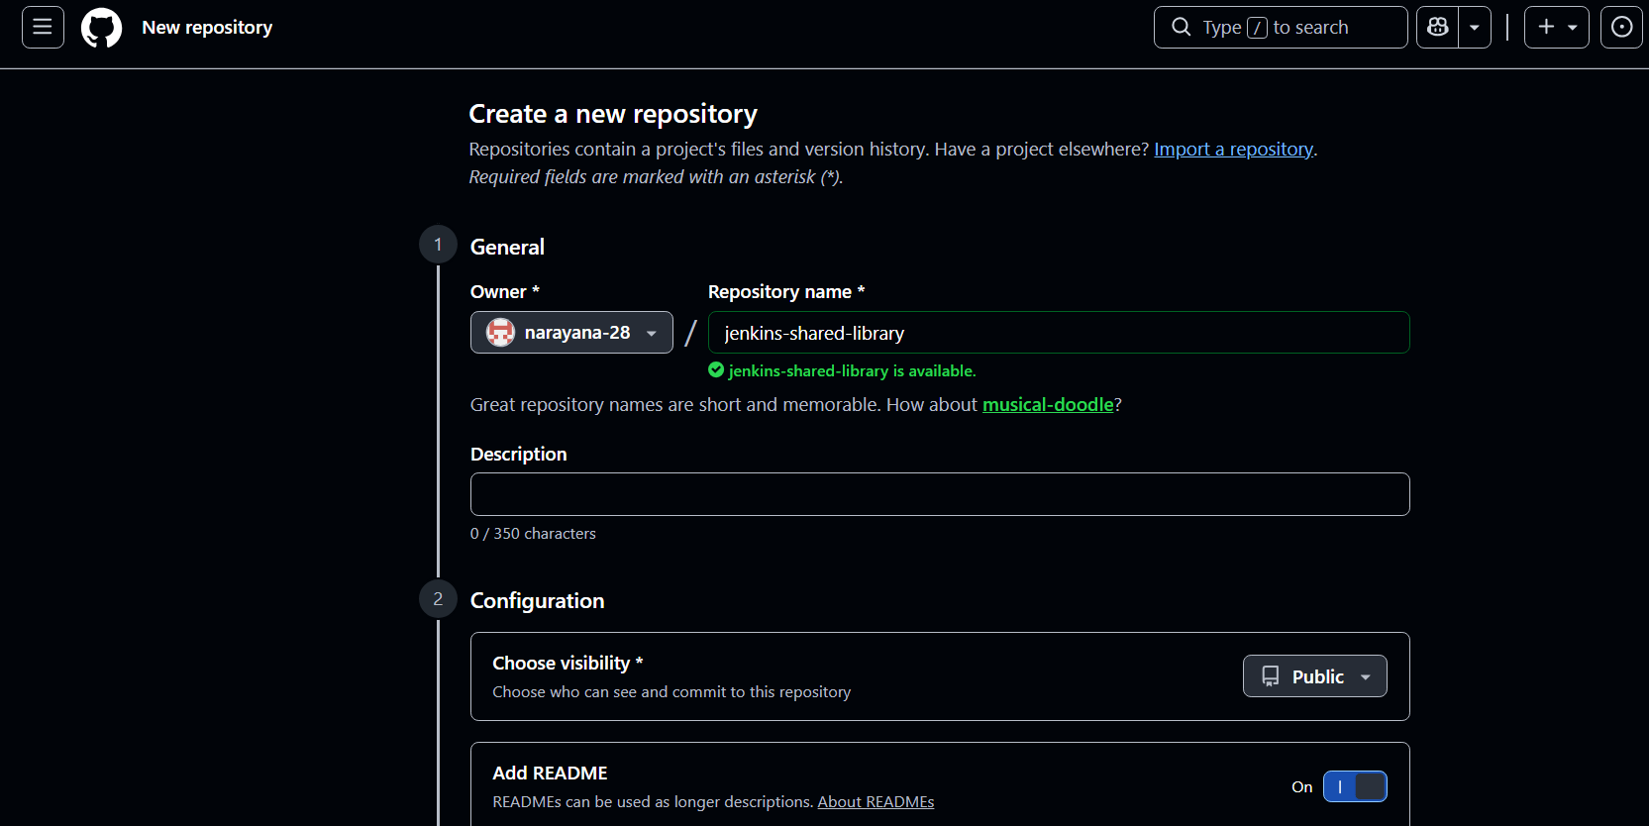
Step 2 — Create the library file
In your new repository, create a folder named vars and inside it a file named ci.groovy.
Your repository structure should look like this:
jenkins-shared-library/
vars/ci.groovy
README.md
Add this code to vars/ci.groovy:
def checkoutSource(String repo, String branch = 'master') {
git branch: branch, url: repo
}
def buildMaven(String goals = 'clean package') {
sh "mvn -B ${goals}"
}
def reportSuccess(String appName) {
echo "${appName} pipeline completed successfully."
}
Click Commit changes.
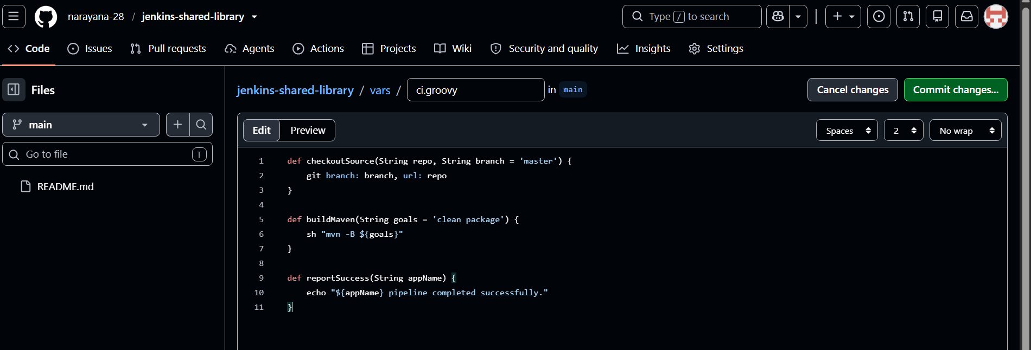
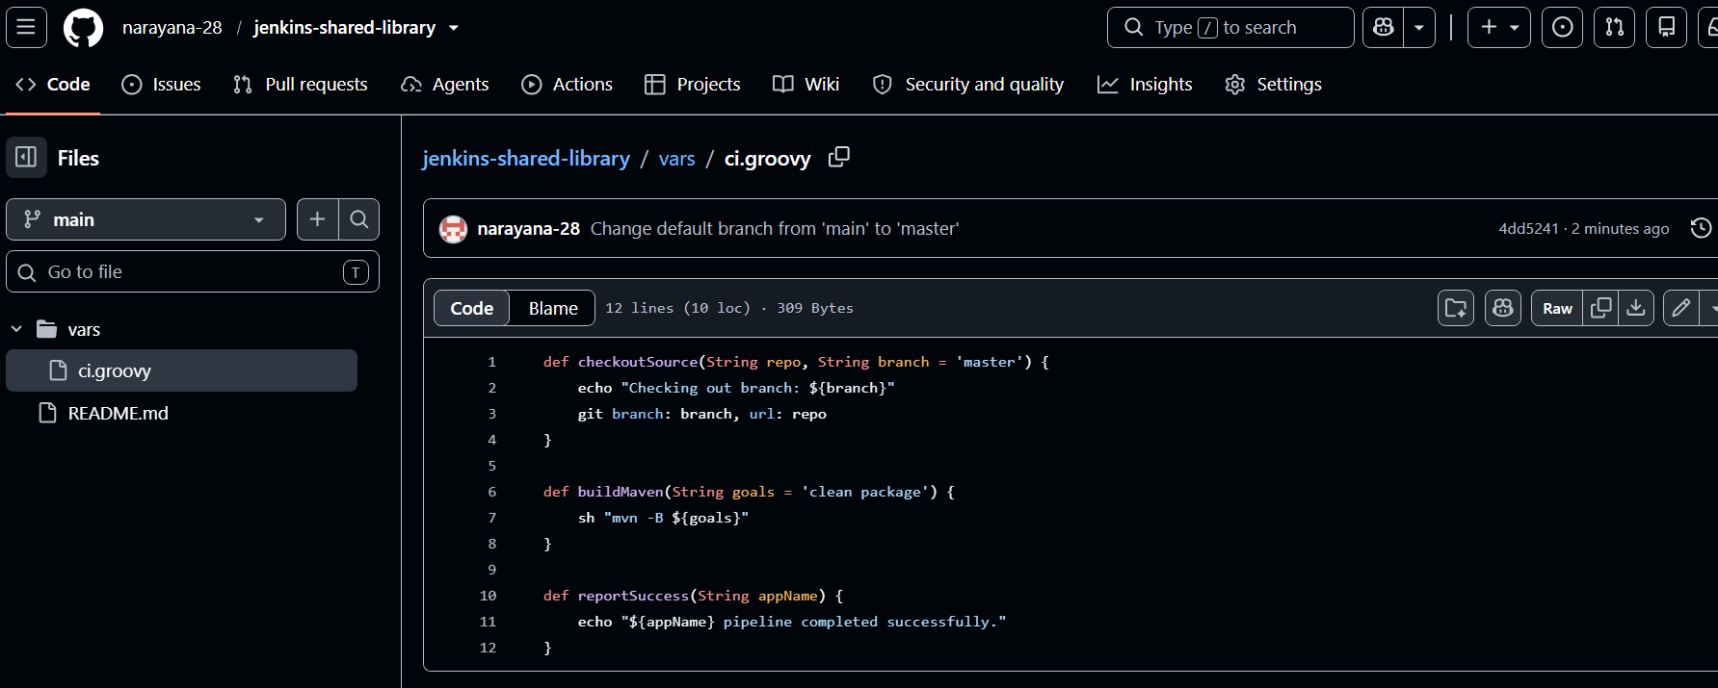
What do these functions do?
- checkoutSource() — checks out source code from Git.
- buildMaven() — runs the specified Maven goals.
- reportSuccess() — prints a success message.
Jenkins exposes functions in vars/ci.groovy through the global library variable ci. This is the standard Shared Library structure.
Jenkins +1
Step 3 — Register the library in Jenkins
After committing the file:
- Open Jenkins.
- Click Manage Jenkins.
- Open System or Configure System.
- Find Global Trusted Pipeline Libraries or Global Pipeline Libraries.
- Click Add.
Enter the following settings:
Setting | Value
Name | jenkins-shared-library
Default version | main
Retrieval method | Modern SCM
Source Code Management | Git
Project Repository | https://github.com/YOUR_GITHUB_USERNAME/jenkins-shared-library.git
Replace YOUR_GITHUB_USERNAME with your actual GitHub username. If your repository uses master instead of main, select master as the default version.
Leave Load implicitly unchecked; we'll load the library explicitly in the pipeline. Then click Save.
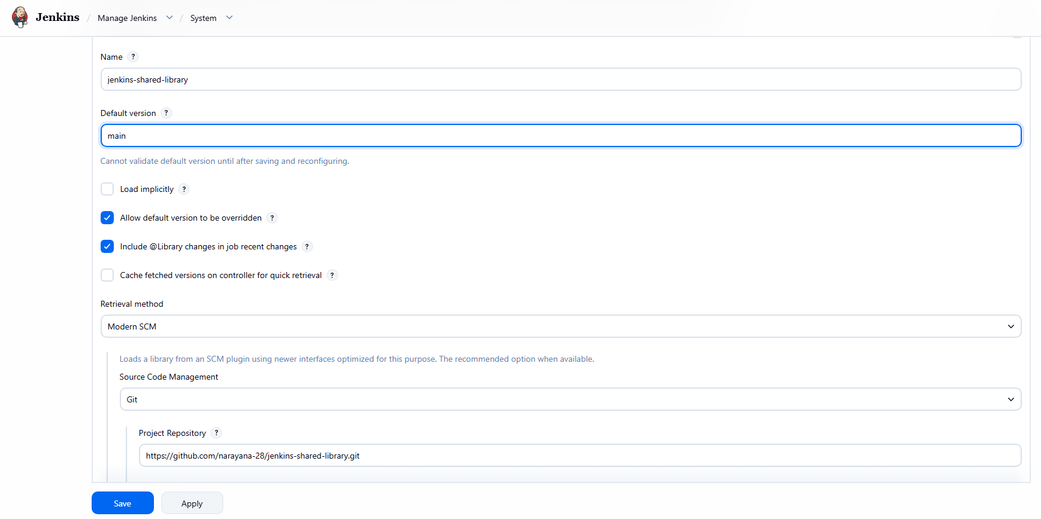
Step 4 — Create a new Jenkins pipeline job
- Open Jenkins: http://54.144.225.176:8080
- Click New Item.
- Enter the job name: shared-library-maven-job.
- Select Pipeline and click OK.
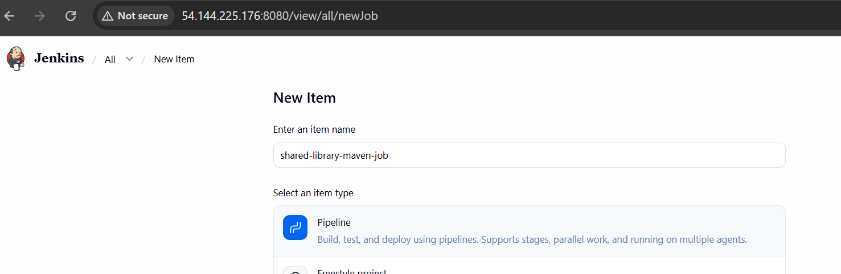
- Scroll to the Pipeline section.
- Set Definition to Pipeline script.
Step 5 — Add the pipeline script
Your GitHub username from the earlier lab is narayana-28. If you created the library under that account, paste this script:

@Library('jenkins-shared-library') _
pipeline {
agent any
stages {
stage('Checkout') {
steps {
script {
ci.checkoutSource(
'https://github.com/narayana-28/spring3-mvc-maven-xml-hello-world-1.git',
'master'
)
}
}
}
stage('Build') {
steps {
script {
ci.buildMaven('clean package')
}
}
}
stage('Verify') {
steps {
sh 'ls -lh target'
script {
ci.reportSuccess('Maven Application')
}
}
}
}
post {
success {
echo 'Shared Library pipeline completed successfully!' }
failure {
echo 'Shared Library pipeline failed. Check Console Output.' }
always {
echo 'Pipeline execution finished.' }
}
}
If your library is under a different GitHub username, update the repository URL in Jenkins' library configuration. The application checkout URL above should remain unchanged.
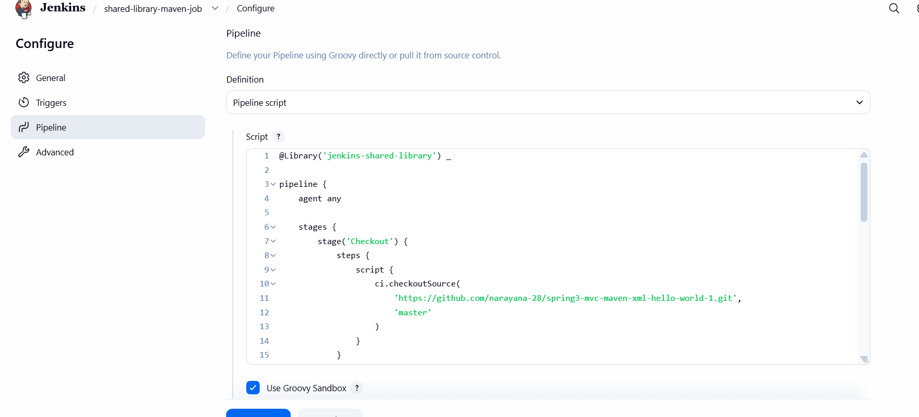
Step 6 — Save and run
- Click Save.
- Click Build Now.
- Open Console Output.
Look for these results:
- The shared library loads successfully.
- Checkout checks out the Maven application's master branch.
- Build runs Maven and reports BUILD SUCCESS.
- Verify lists the generated WAR file.
- The final result is Finished: SUCCESS.
